Average Face Pipeline

The core objective of this pipeline is to synthesize a single “Average Face” for our 8 pre-defined expressions across our two social groups.
Our architecture utilizes a four-stage hybrid pipeline combining computer vision geometry, multi-scale signal processing and constrained generative AI for a clean result.
Feature Localization & Alignment:
The pipeline standardizes the global spatial frame of every input image to ensure that physical disturbances like head tilting and distance from the camera do not skew the average. A yolod etection model isolated the primary bounding box of the face, then a Dlib facial boundary model detects 68 distinct anatomical coordinates on the bounding box as shown below by examples for the “positive social expression” peaks in Group A:
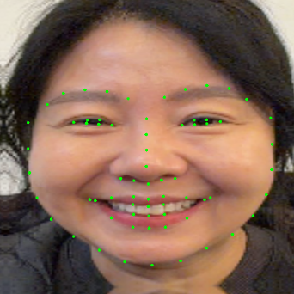
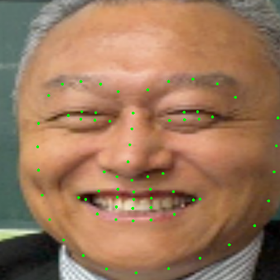
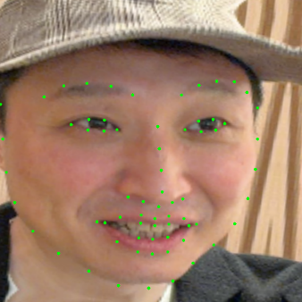

Figure 1. Dlib detection landmark examples in Group A
We calculate the pixel displacement vectors of the eyes on our current image as: ∆x = X_{R} – X_{S} and ∆y = y_{R} – y_{S}, where Variable_{R} is the coordinate center of the right eye and Variable_{S} is the coordinate center of the left eye. Once we have the internal eye vector (∆x, ∆y), we use the properties to deduce exactly how tilted and how large the participant’s face currently is, allowing us to compute the correction factors needed to map it perfectly onto our 600 X 600 target canvas, namely rotation angle (θ) and scaling factor (s):
$θ=arctan2\left(∆y,∆x\right)$ – arctan2 preserves the signs of both components
d_{current =} $\sqrt{{(∆x)}^{2}+{(∆y)}^{2}}$ , our desired we fix the desired d as 220 on our canvas
s = $\frac{d_desired}{d_current}= \frac{220}{\sqrt{{(∆x)}^{2}+{(∆y)}^{2}}}$
If s > 1, the participant was too far away and the algorithm needs to zoom in, and vice versa.
This allows us to treat the eyes as an immutable structural anchor, which the algorithm uses to calculate a rigid 2 X 3 transformation matrix, called the affine transform matrix, to rotate, scale, and translate the coordinate to horizontally level and lock every image at a target coordinate (200,250) on a standard 600 X 600 canvas.
Non-rigid shape normalization (Morphing)
Even after alignment via eyes, individual structural proportions like nose width, chin length, etc, vary drastically. This part of our code maps all individual faces onto a perfectly synchronized geometric framework. We solve the proportion misalignment by mathematically representing the shape configurations as co-ordinate matrices. For a given participant, their landmark structure is defined as a 68 X 2 matric S:
$$S = \left[\begin{matrix}x_{1} & y_{1} \\ x_{2} & y_{2} \\ ⋮ & ⋮ \\ x_{68} & y_{68}\end{matrix}\right]$$
Once our landmark matrices S are established, we zero-center them by subtracting their geometric mean µ and scale by their Frobenius norm $\left\|S- µ\right\|$ so that the total spatial variance equals 1 – this strips away any lingering size differences among participants. As a result, we get the S_{norm} parameter, which serves as a shape-standardized landmark matrix for an individual participant:
$$Snorm= \frac{S- µ}{\left\|S- µ\right\| }$$
We then average this parameters across each participant and compute S̄, our target mean shape which serves as a definitive geometric master anchor for the entire cohort. It represents a single 68 X 2 matrix containing the exact point-by-point average location of every facial feature across all N participants. We then sub-divide the average geometry into a mesh using Delaunay Triangulation, allowing us to organize the 68 points into a collection of adjacent, non-overlapping triangles. For every single triangle index created on the target mesh, the algorithm looks at that exact same triangle on an individual participant’s face. Then a localized affine transformation matrix A_{local} is calculated to map the sources vertices linearly onto the target vertices. The pixels within each triangular domain are then warped according to $I_{target} (\overline{x},\overline{y})= I_{\left(source\right)}\left(A_{local} . {\left[x,y,1\right]}^{T}\right)$, where $(\overline{x},\overline{y})$are the co-ordinates of a pixel on the target canvas and $(x,y)$ are the coordinates of the corresponding pixel in the source image. This step forces all facial features into geometric alignment before blending.
Spatial Frequency Blending
To prevent phase cancellation artifacts from blurring high-frequency details, the pipeline decomposes images into independent frequency components before blending. For each warped participant image, a 3-level Gaussian Pyramid (G_{0,} G_{1,} G₂) is constructed via progressive low-pass filtering and downsampling. From this, a Laplacian Pyramid (L_{0,} L_{1,} L₂) is derived to isolated exclusive spatial frequency domains:
$$L_{j}= G_{j}- resize \left(pyrUp\left(G_{j+1}\right)\right)$$
L_0 -> captures high-frequency edge transitions and fine pores.
L_1 -> captures mid-frequency structural shading.
L_2 -> captures low-frequency, global illumination gradients.
Instead of averaging raw pixels, which leads to muddy results, the pipeline calculates the mean of the Laplacian layers independently across all N participant images at each discrete level:
$$\overline{L_{j}}=\frac{1}{N}\sum_{k=1}^{N}{L_{j,k}}$$
The final unrefined average image is reconstructed by upsampling and accumulating the average laplacian residuals back together:
$$I_{blended}= \overline{L_{2}}+ pyrUp\left(\overline{L_{1}}+ pyrUp\left(\overline{L_{0}}\right)\right)$$
Optional AI refinement
An optional AI refinement step is introduced for realism. We use a Stable Diffusion XL Image-to-Image pipeline after the reconstructed average with a highly conservative denoising threshold (0.12) to preserve the average face and not distort any emotions or facial structure. To guarantee that the generative model does not introduce structural hallucinations or alter semantic expressions, the pipeline enforces strict geometric boundary masking before creating the final output. This is done by closing the forehead boundary mathematically using a pair of quadratic Bezier cruves anchored from the temples (P₀) through localized control boundaries (P₁) to the mid-brow apex (P₂): $B\left(t\right)= {\left(1-t\right)}^{2}P_{0}+ 2\left(1-t\right)t P_{1}+ t^{2}P_{2}, t∈\left[0,1\right]$
The pipeline isolated the pure mathematical lips and eye contours. It then applies a soft Gaussian-blurred spatial weight mask to seamlessly graft the unaltered empirical data from the blending step directly over the generative texturing:
$$I_{final}= I_{generative}⋅\left(1 - M_{smooth}\right)+ I_{empirical}⋅M_{smooth}$$

This final step guarantees that the delicate muscle activations measured in our empirical cohort matrix remain structurally untouched, while the surrounding face exhibits a clean, presentation-ready portrait format, allowing us to inject sub-pixel realism and clean up significant distortions in the original average face while not changing the emotion or facial structure. An example is shown below:
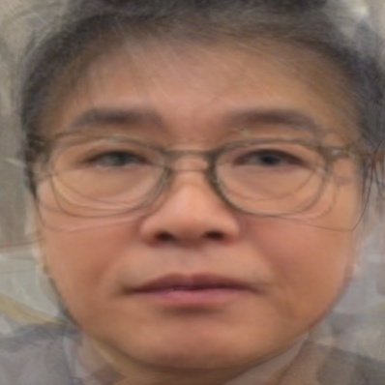
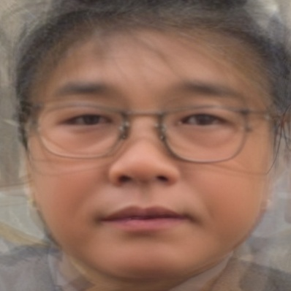

Figure 2. Dejection Average Face for Group B a) before refinement, b) after refinement
A comprehensive flow diagram summarizes our work which was initially tested on 22 candidates to form an average neutral face:
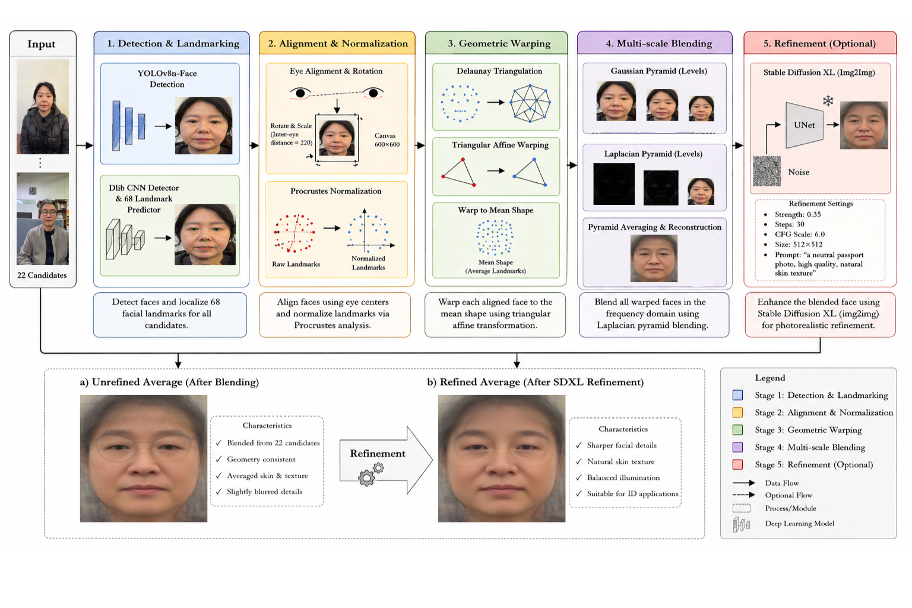

Figure 3. Average Face Pipeline Flow Diagram

